Vitrek’s 98x Series Teraohmmeter Meets Demands for Higher Voltage IR Testing
Meets requirements for emerging higher voltage electric vehicle battery system and solar array insulation
resistance testing; offers unique combination of operational features; capacitive load capability facilitates
solar system and cable harness testing
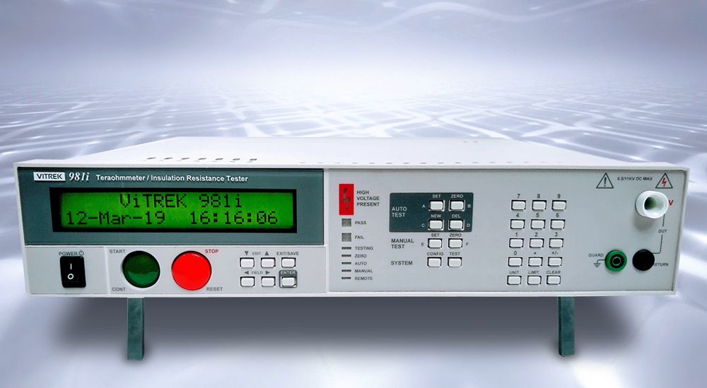
Poway, CA—March 21, 2019—Vitrek, the leader in high-voltage test and measurement equipment, introduces the 98x Series of Teraohmmeter / Insulation Resistance testers designed to meet the emerging higher voltage requirements of electric vehicle battery systems and solar arrays. The 981i offers an output voltage range of up to 6.5 kV and the 983i has a maximum output of 11 KV.

[Click image to download high-res JPEG]

Built upon the same DSP technology that has established Vitrek as a leader in hipot test systems, the 98x devices feature a unique combination of performance features including:
- Multi-dwell Functionality (multiple steps without having to return to zero between steps)
- High-speed Testing (with dwell times as low as 100 ms)
- Pico-Amp Leakage Measurement (with stable and precise 50 Teraohm IR readings)
- Continuously Variable IR Test Voltage (adjustable over the full output range of the instrument)
- Multi-mode IR (three test modes – end on time, end on pass, end on fail)
- Capacitance Test Modes (critical for solar panels, cable harnesses and other capacitive loads)
For applications requiring IR testing of multiple conductors, the Vitrek 98x IR Testers have the capability of directly controlling up to four 64-channel Vitrek 964i high-voltage scanners. Utilizing a PC equipped with Vitrek’s QT Enterprise™ software, the same instrument can handle up to 1020 test points.
“The trend in power conversion systems is toward higher and higher operating voltages to increase operational efficiency,” said Chad Clark, Vitrek’s Director of Sales and Marketing. “The Vitrek 98x IR Testers are designed to meet today’s requirements and those for many years to come.”
Vitrek 98x Insulation Resistance Testers are safety tested per EN 61010-1 and are EMC compliant to
EN 61326-1. In addition to providing a 1-year standard warranty, an extended three-year warranty is offered including annual factory calibration. (Click here to download complete specifications for the Vitrek 98x)

Price: $4,995. (981i); $5,995. (983i)
Delivery: In Stock

About Vitrek
Since 1990, Vitrek has provided innovative global solutions for high voltage test and measurement including electrical safety compliance testers, multi-point high-voltage switching systems and graphical power analyzers. Vitrek also supplies precision high voltage measurement standards to national laboratories and calibration labs around the world. This unique combination of capabilities positions Vitrek as a leading provider of test solutions serving the photovoltaic, medical equipment, power conversion, electrical component and appliance industries.

Company Contact:
Chad Clark, Director, Sales & Marketing
Vitrek, Inc.
858.689.2755 x203

chad@vitrek.com

www.vitrek.com
Agency Contact:
Greg Evans • Acct. Exec.
WelComm, Inc.
Direct: 858-633-1911
greg@welcomm.com
www.welcomm.com

