
Vitrek 4700 Makes Compliance with Global ISO 17025
Voltage Standards Simpler & Less Costly

Product’s Diverse Capabilities & Built-In Compliance Simplify Set-up and Cut Out $2,000+ in Upfront Calibration Costs.

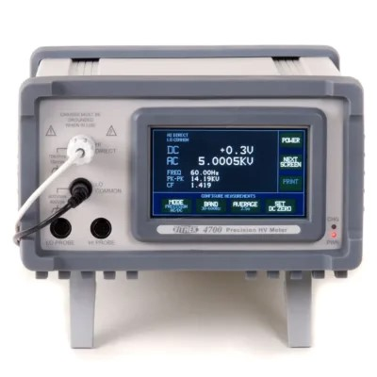
Lockport, IL-December 4, 2025– Vitrek’s 4700 Precision High Voltage Meter is gaining recognition as the simplest deployment-ready solution for laboratories looking to achieve ISO/IEC 17025—a compliance requirement needed for a growing number of medical device, aerospace, and energy devices worldwide.
This comes as the global test and measurement market, valued at $38.9 billion in 2024, is experiencing accelerated growth driven by compliance requirements. *

With thousands of units already deployed worldwide, the 4700 is not new technology—but its relevance has never been greater. Vitrek's simple, compliance-ready approach has made the 4700 the preferred meter for laboratories that cannot afford measurement uncertainty.

The 4700 can handle the full array of needed ISO/IEC 117025 tests that would otherwise require multiple devices. Also, unlike traditional high voltage meters requiring expensive external calibration, the 4700 includes ISO 17025-accredited certification out-of-the-box, eliminating $800-$1,500 in initial compliance costs and significantly reducing audit prep time.

“Standard equipment voltage ranges have increased in many industries and ISO 17025 compliance has shifted from 'nice to have' to 'business critical' in just 18 months," said Bryan Withers, Vitrek’s VP of Engineering. "The 4700 transforms compliance from a $2,000 initial cost into a competitive advantage while delivering the unmatched 0.03% accuracy that precision-critical applications demand.
Vitrek's trusted 4700 Precision High Voltage Meter fits a growing sweet spot as calibration laboratories and compliance-focused manufacturers respond to the need to address supply voltages that typical voltage meters are unable to measure. Traditional approaches to achieving ISO 17025 compliance for high voltage measurement typically require:
• Initial Integration with Companion Devices: 8-16 hrs by specialized engineers
• System uncertainty analysis: Requiring dedicated expertise
• External calibration: $800-$1,500 per device(s)
- Adoption delay: 2-4 weeks-- calibration and transit
“Recent adopters have reported a 60-80% reduction in initial compliance prep time,” added Withers.
The Vitrek 4700 is widely deployed in labs and manufacturing test environments where high-voltage measurement precision is mission critical. Industry analysts note that ISO 17025 requirements will become universal across all safety-critical sectors within 3-5 years, making early adoption a strategic advantage for forward-thinking organizations.

About Vitrek

Vitrek is a driving innovation through our family of industry-leading brands: Vitrek, GaGe, and MTI Instruments. Our product portfolio includes high-speed, high resolution digitizer cards, precision power analyzers, AC/DC hipot testers, insulation resistance meters, non-contact measurement products and turbine engine balancing systems. In addition to standalone instruments, Vitrek offers turnkey automated electrical safety test stations, complete with barcode integration and test automation software.

