
Vitrek Launches New Test & Measurement Solutions Catalog
Showcases Advanced Electrical Safety & High-Voltage Testing Technologies

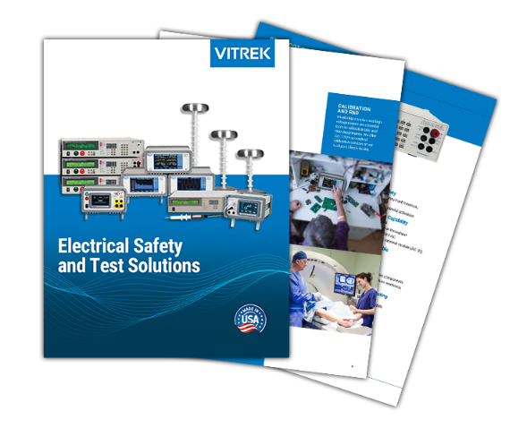
Lockport, IL—March 4, 2026— Vitrek, a U.S.-based manufacturer of high-performance electrical safety and precision measurement equipment, announced the release of its newly updated Electrical Safety Test & Measurement Solutions Catalog.
Widely regarded as a trusted industry reference, the catalog supports global manufacturers, national laboratories, government agencies, universities, and distributors who depend on Vitrek expertise in high-voltage testing, noncontact measurement, metrology, engine balancing, and high-speed data acquisition.
“Vitrek has built its reputation on precision, performance and trust,” said Chad Clark, Vitrek’s Vice President of Sales. “This updated catalog reflects the depth of our portfolio and makes it easier for customers worldwide to identify solutions that meet today’s increasingly rigorous performance and compliance requirements.” The new edition—available online at Vitrek.com and through authorized Vitrek sales representatives—provides comprehensive overviews of the company’s U.S.-designed and manufactured product portfolio, including:
- Hipot testers, including the new V10x Series • High voltage switching & cable test systems
- Teraohmmeters and insulation resistance testers • High-voltage measurement systems
- DC electronic loads • Precision power analyzers
- QT Insite™ test management software
Each section includes global standards support, application guidance, key features and benefits, model comparison charts, and detailed specifications—helping engineers, quality managers, and procurement teams confidently select the right solution.
Vitrek technologies support critical industries including aerospace and defense, automotive, medical device manufacturing, industrial equipment production, calibration laboratories, and research and development. The updated catalog underscores the company’s continued commitment to precision, regulatory compliance, and innovation across highly regulated markets.
About Vitrek

Vitrek designs and manufactures precision electrical safety and measurement solutions used across aerospace, electric vehicle, medical device, research, and advanced manufacturing environments. Its core portfolio includes precision voltage sources and analyzers, hipot testers, high-voltage switching systems, DC electronic loads, and power analyzers engineered for demanding global standards.

The Vitrek family of brands also includes MTI Instruments, providing capacitive measurement systems and jet engine balancing solutions, and GaGe, known worldwide for high-speed, high-resolution digitizer cards with exceptional application flexibility.

