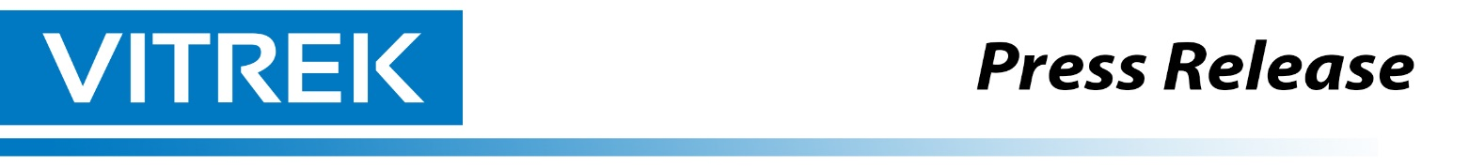
Vitrek Introduces Intelligent Cable Test Automation Solution Combining V10X Hipot Platform and 964i High-Voltage Switching System

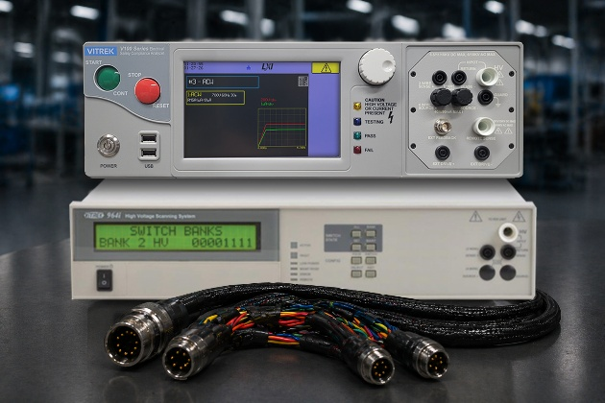
Lockport, IL—May 28, 2026 — Vitrek, a U.S.-based manufacturer of precision electrical safety and high-voltage test equipment, announced an advanced cable testing solution that combines the power of the Vitrek V10X Hipot Tester with the scalability of the Vitrek 964i High Voltage Switching System to help manufacturers automate high-voltage cable validation, improve throughput, and strengthen quality assurance.

As cable assemblies become more complex across EV platforms, aerospace systems, medical devices, industrial automation, and defense electronics, manufacturers need faster ways to validate insulation integrity, dielectric withstand performance, continuity, and wiring accuracy—without increasing operator burden.

The combined V10X + 964i platform transforms traditional point-by-point cable testing into an intelligent automated workflow. Key capabilities include:
- Automated routing across multi-conductor cable assemblies
- High-voltage AC/DC hipot testing & leakage current detection with high sensitivity
- Reduced manual fixturing and setup time & barcode-enabled operator workflows
- Built-in PDF/CSV reporting for digital traceability
- Scalable architecture for complex harnesses and production growth

The V10X delivers up to 30 kV AC output with modern touchscreen control, automation interfaces, and integrated reporting, while the 964i expands testing across multiple conductors and test points through configurable high-voltage switching cards.

“Cable manufacturers are under pressure to increase output while proving every assembly meets higher safety and reliability expectations,” said Chad Clark, VP Sales at Vitrek. “This solution helps customers move beyond slow manual testing into fully automated, data-driven validation.”

The platform is ideal for manufacturers of:
- EV charging cables and battery harnesses
- Aerospace wire bundles & medical cables and patient assemblies
- Industrial machine wiring harnesses & defense and ruggedized interconnect systems

For more information, visit Vitrek.com.

About Vitrek

Vitrek is a leading U.S.-based manufacturer of precision test and measurement equipment for electrical safety, power analysis, high-voltage measurement, signal recording, and non-contact metrology applications. Serving industries including aerospace, automotive, medical, energy, electronics, and research, Vitrek helps engineers improve product safety, performance, and compliance through accurate, reliable, and automation-ready solutions.

