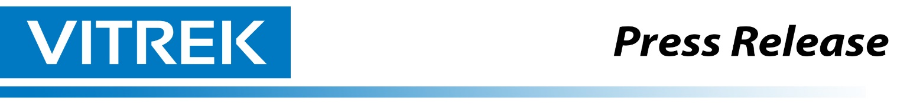
PBS eXpress Engine Vibration Technology Debuts at Aerospace Test & Development Show

A Transformative Opportunity for Regional and Business Operators
-----------------------------------------------------------------------------------------------------------------------------------------

Lockport, IL, [Date] – Vitrek, LLC (“Vitrek”), a leader in high-performance test and measurement equipment, announced today that it will showcase its PBS eXpress Vibration Measurement and Engine Rotor Balancing System at the Aerospace Test & Development Show on September 30 - October 1 in Toulouse, France. While launched in the U.S., this marks the system’s first major demonstration at a European industry event.
Developed by Vitrek, the MTI PBS eXpress is designed specifically to optimize engine balancing for the smaller-frame turbofan and turboprop engines widely used in regional, business, and general aviation. The system quickly and reliably identifies and resolves vibration issues that can lead to costly maintenance. It delivers the same automated, core precision balancing capabilities of the flagship PBS-4100+ now widely used for large frame commercial jet liners like those from Boeing and Airbus among others.
PBS eXpress Trim Balance Wizard Ideal for Non-Specialists
The Trim Balance Wizard technology integrated into the PBS eXpress turbine balancing system. iIncludes a guided interface that transforms complex jet engine balancing from a specialist-only procedure into an easy, step-by-step process that relatively untrained users can complete from set up to success in as few as two engine runs. Traditional balancing procedures require an extensive knowledge of vibration analysis, weight placement calculations, and iterative correction processes. MTI's Trim Balance Wizard automates complex calculations while maintaining the precision standards required for safety-critical applications.
“PBS eXpress has the DNA and rapid turn-around features of our PBS-4100+ family of upmarket engine balancing systems, but in an easy, compact package to meet corporate aviation needs,” says [Ken Ameika, Vitrek VP of Sales. “This advanced automation aligns perfectly with the fleet modernization, cost efficiency and strict regulation of today’s European MRO landscape. It will help smaller operators without larger facilities and specialized staffing thrive within the industry’s ongoing technological transformation.”
Also showing at the Aerospace Test & Development Show will be Vitrek’s PBS-4100+ and PBS-4100R+, designed to maximize the performance and longevity of larger commercial turbine engines. Applications include vibration surveys, spectral analysis, fan/turbine balance, transient balance and propeller balance.

About Vitrek
Vitrek is a driving innovation through our family of industry-leading brands: Vitrek, GaGe, and MTI Instruments. Our product portfolio includes high-speed, high resolution digitizer cards, precision power analyzers, AC/DC hipot testers, insulation resistance meters, non-contact measurement products and turbine engine balancing systems. In addition to standalone instruments, Vitrek offers turnkey automated electrical safety test stations, complete with barcode integration and test automation software
Download a copy of this press release

