
Vitrek to Showcase Transformative Accumeasure™ Capacitance Sensors at SEMICON West 2025
Bringing a New a Level of Precision, Affordability for Semiconductor Wafer Makers
-----------------------------------------------------------------------------------------------------------------------------------------
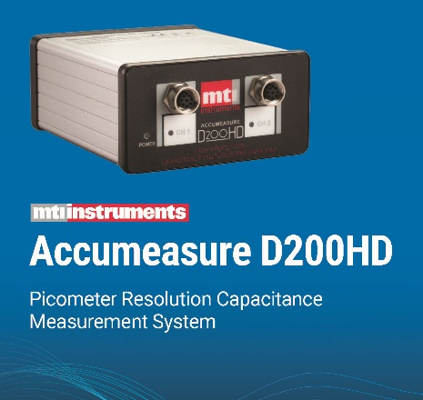
Lockport, IL, October 1, 2025 – Vitrek, LLC (“Vitrek”) a leader in high-performance test and measurement equipment, announced today that it will showcase its expanded Accumeasure capacitance measurement product line at the SEMICON West exhibition on October 7-9, 2025, at the Phoenix Convention Center in Phoenix, Arizona.

Along with the established Accumeasure analog and digital test systems will be samples of the Accumeasure HD, offering the highest-resolution non-contact capacitance system in the world. Developed and manufactured in the US, the Accumeasure HD system is a capacitance- based, displacement measurement instrument for ungrounded targets.
The extremely high-precision and high linearity of the rugged Accumeasure capacitance probes makes them ideal for wafer position applications. The rugged probes are not affected by magnetic fields, temperature, humidity, nuclear radiation, and pressure.

Accumeasure HD Shown to Have Highest Resolution

“Accumeasure HD is a potential game changer for semiconductor manufacturers and others who depend on precise thermal-displacement measurements. It’s not only the most advanced capacitance displacement system developed, but it also stands up well against more costly laser interferometers, which have been the standard tool for achieving this level of accuracy,” said Ken Ameika, VP of Global Sales.

The Accumeasure HD was independently tested by Kevin Harding of Optical Metrology Solutions. Corroborated by Vitrek experiments, the results showed that the Accumeasure HD system can provide picometer-level resolution when used with 50-micron HD capacitive probes. The system was able to measure distances as small as 70 picometers, at the time setting a new bar for capacitance systems.

“Engineers kept asking for higher resolution to support performance and yield, so the company developed and prototyped the HD product to match anticipated requirements,” says Pete Opela, VP of Engineering. “
------------------------------------------------------------------------------------------------------------------------------------------
About Vitrek:

Vitrek products are widely used in the aerospace industries, electric vehicles, medical, research and development markets, as well as by a wide variety of manufacturing industries. Vitrek product lines include a broad line of precision voltage generators and analyzers as well as hipot testers and switches.
The Vitrek family of brands also includes: the MTI lines of jet engine balancing products and capacitive measurement solutions as well as; the GaGe digitizer cards which are recognized worldwide for combining high speeds with high-resolution and application flexibility.

